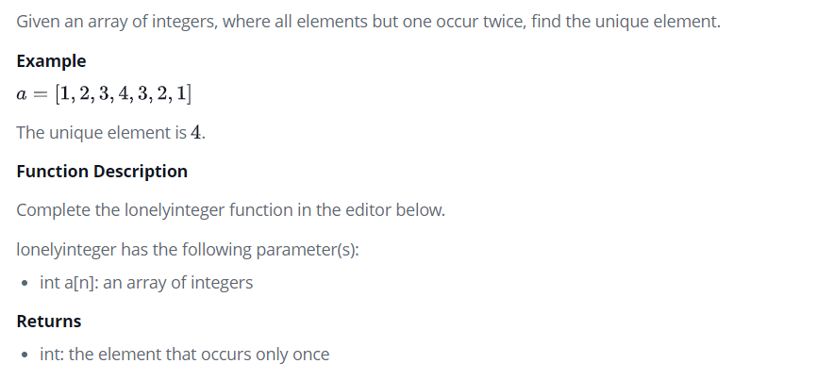

CODE:

<script>

var list=[1,2,3,4,3,2,1,5];

var len=list.length;

for(var i=0;i<len;i++)

{

if(list.indexOf(list[i]) == list.lastIndexOf(list[i]))

document.write(list[i]+",")

}

</script>